AI Assisted Coding
ASSIGNMENT 1.2
Name: S.Nidhi Kathyayini
HT No: 2303A52015
Batch :31
Question 1:
Task 1:
AI-Generated Logic Without Modularization (Factorial without Functions) Scenario You are building a small command-line utility for a startup intern onboarding task. The program is simple and must be written quickly without modular design. Task Description Use GitHub Copilot to generate a Python program that computes a mathematical product-based value (factorial-like logic) directly in the main execution flow, without using any user-defined functions. • Constraint: Do not define any custom function Logic must be implemented using loops and variables only
Prompt:
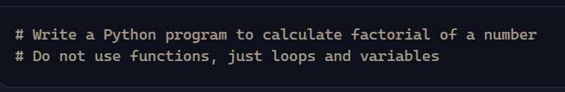
Code Screenshot:
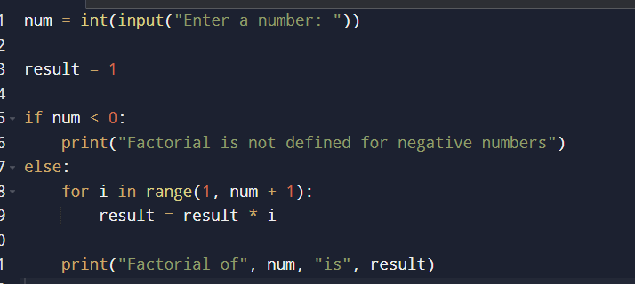
Out put:
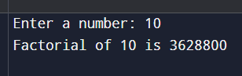
Explanation :
- GitHub Copilot is very helpful for beginners because it can quickly generate working code from simple prompts.
- However, it may not always follow best practices automatically (like handling negative inputs or adding comments).
- Beginners should review and test Copilot’s suggestions instead of copying blindly.
- Adding meaningful variable names, comments, and error handling improves readability and maintainability.
- My suggestion: always treat Copilot’s output as a starting point, then refine it to match good coding standards.
Question 2:
Scenario Your team lead asks you to review AI-generated code before committing it to a shared repository. Task Description Analyze the code generated in Task 1 and use Copilot again to: Reduce unnecessary variables Improve loop clarity Enhance readability and efficiency Hint: Prompt Copilot with phrases like “optimize this code”, “simplify logic”, or “make it more readable”
Prompt:
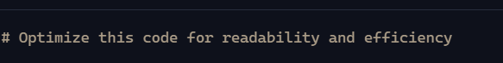
Code Screenshot:
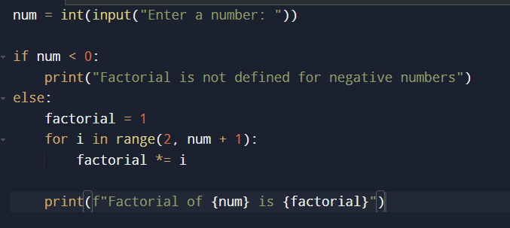
Out put:
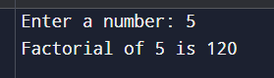
Explanation:
Optimized the code in minimal number of lines and short variable names
Question 3:
Scenario:
The same logic now needs to be reused in multiple scripts. Task Description Use GitHub Copilot to generate a modular version of the program by: Creating a user-defined function Calling the function from the main block Constraints: Use meaningful function and variable names Include inline comments (preferably suggested by Copilot)
Prompt:
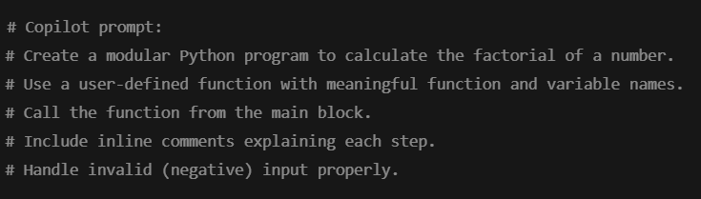
Code Screenshot:
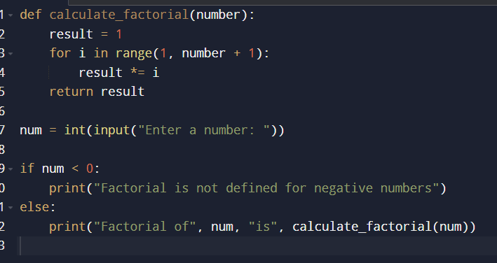
Out put:
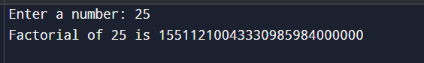
Explanation:
Copilot Modified The Code To Function Type & main block is created Handled Edge Cases Well
Question 5:
Scenario:
Your mentor wants to test how well AI understands different computational paradigms. Task Description: Prompt Copilot to generate: An iterative version of the logic A recursive version of the same logic Constraints: Both implementations must produce identical outputs Students must not manually write the code first
Prompt :

Code:
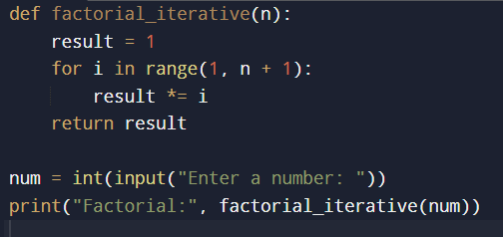
Out put:
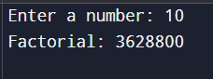
Code:
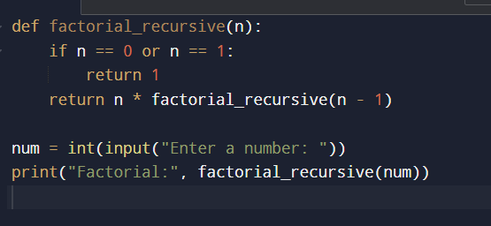
Out put:
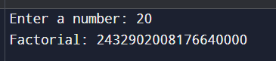
Iterative version: The program starts with an initial value and repeatedly updates it using a loop until the condition is satisfied. The control flow stays within a single function and finishes once the loop ends.
Recursive version: The program calls itself with a smaller input each time. Each call waits on the stack until the base condition is reached. After that, results are returned step by step.

